Graphics
Design
To keep our functions simpler we have a display structure which contains information about the window and the renderer. We use a single renderer to render all of our images. In parts of the game involved in rendering we opted to only need to pass our display structure.
We decided that the player control should be simple to understand with as few interactive elements in game as possible. This is why we settled on the choice to have all of the player control in the buttons. These were clickable buttons that toggle between using an ability and not using it, the only other interaction a player can make is skip through the brief enemy introductions and quit out of the game.
Button logic
To simulate a button an area was created using an SDL Rect structure which specified an area on the window. The programme checks if the cursor is within this are. When the user issues a mouse click while the cursor is within this area a value is toggled to capture the choice the user is making, this could be repeated for all of the buttons available to the player. As well as capturing the logic to return to the state machine, we use this value to change between displaying two different images, one to represent an ability not being used and the other to represent the ability will be used. Values for each of the buttons are added together to create a unique value for each possibility of selected buttons. Another special button was also implemented this one was used to commit the player’s decision which is returned to the game logic, before this commit button is used the player is able to make as many alterations to their selection as they please.
To avoid hard coding in each of the different button images we opted to have a file containing the names/paths to the buttons. We were then able to search through this file for the button we want to render.
Attack Animations
The attacks used in the game are designed to not only move statically across the screen but also rotate about an axis. We chose to add this feature because the game felt a bit too static and non-engaging. To accomplish this feature, instead of using a single image we use a sprite clip, this is an image containing the phases of the animation we want to use as shown in the diagram below. We start by looking at the first instance of the spell and rendering it to the screen the area we look at is then shifted along (by 250 pixels in our case) this instance of the spell is used the next time the image is being rendered.
When the spell moves across the screen it travels a set distance, this distance is sufficiently long that the spell can be reflected if the attack is unsuccessful. Upon multiple attacks the programme will always go in the order.
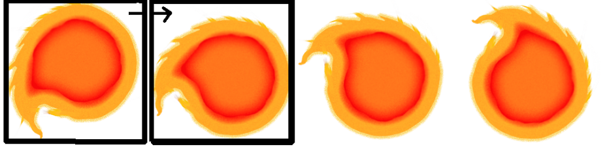
Fire -> Ice -> Lightning
Diagram n. Image shows how an area of the image is selected and used this area then moves on to the next part of the sprite clip.

